***Documentation of Weekly Assignment 7***

*Question_1.py*

*Figure:*

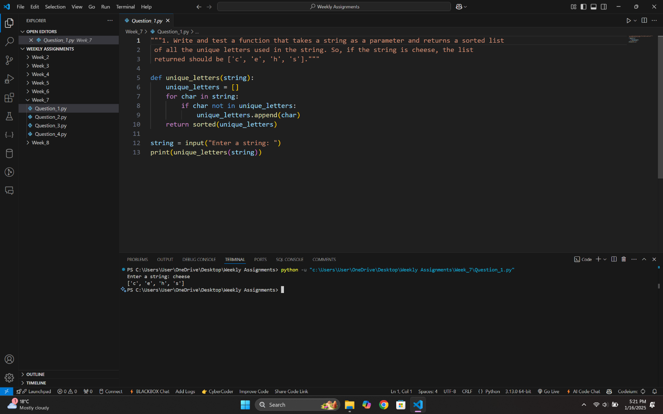

*Question_2.py*

*Figure:*

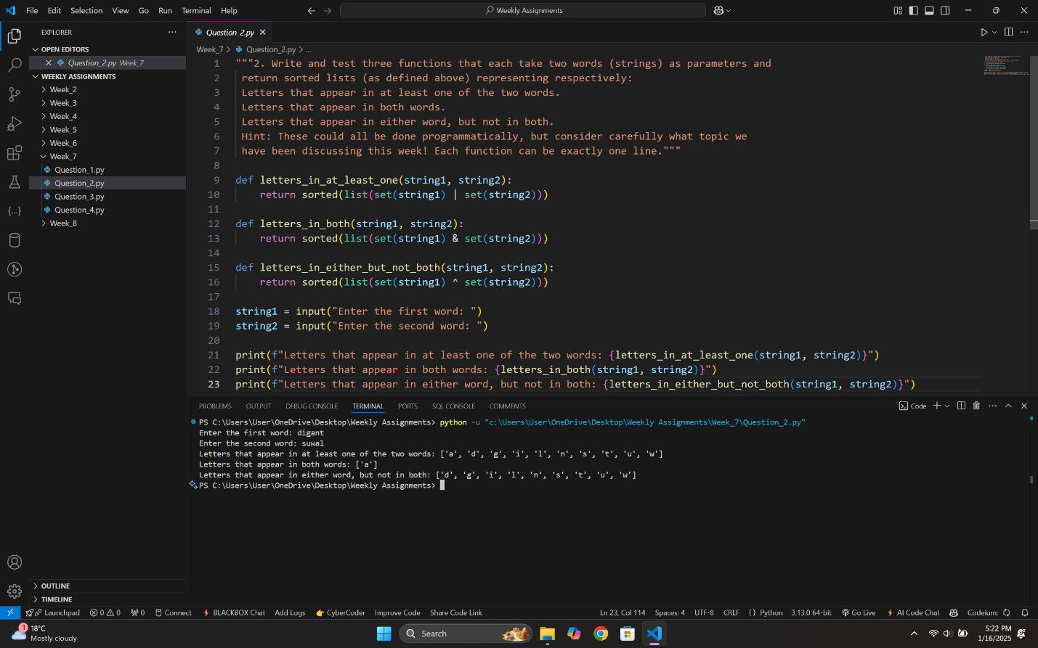

*Question_3.py*

*Figure:*

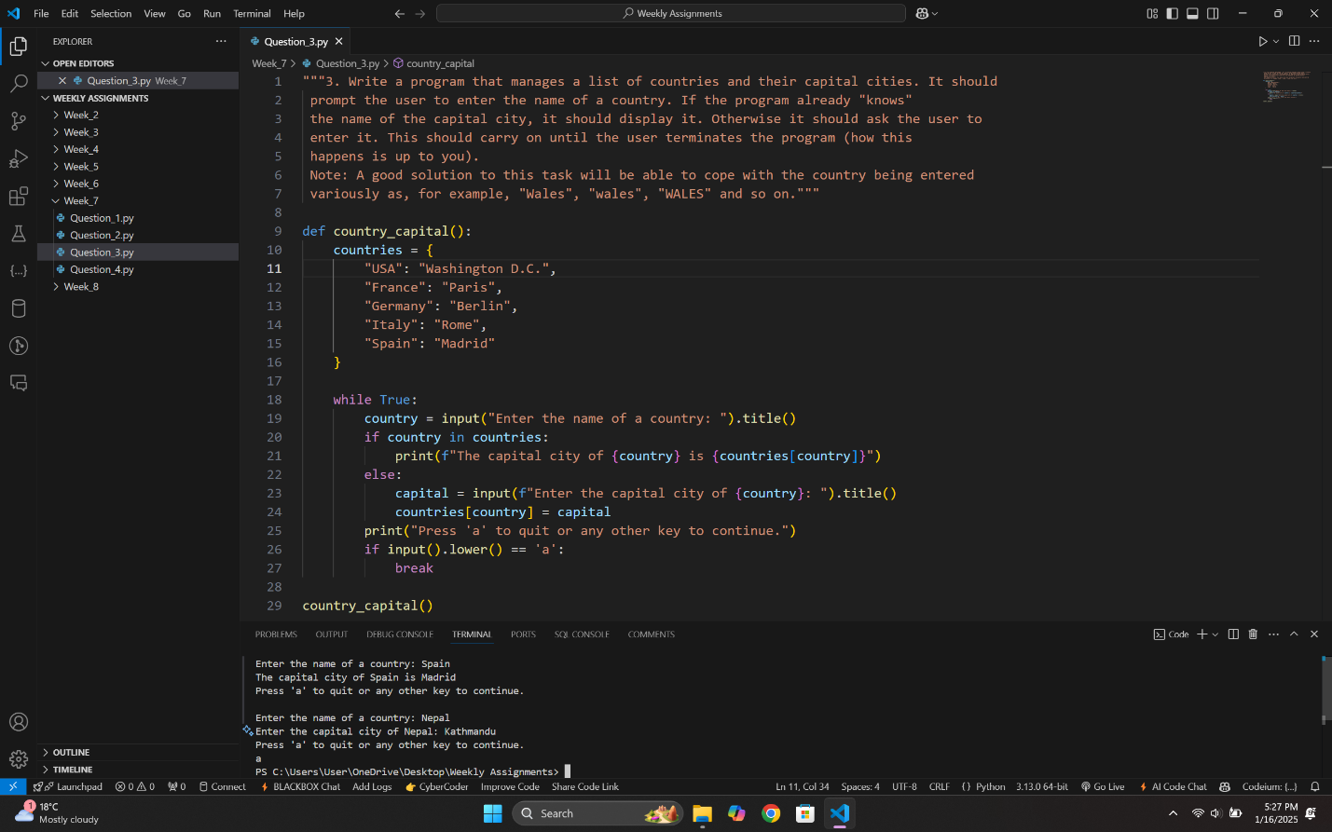

*Question_4.py*

*Figure:*

